PROJECT DEVELOPMENT PHASE
MODEL PERFORMANCE TEST
ServiceNow Script-Controlled ACL Project
Date | 03 October 2026
Team ID | Enter assigned Team ID
Project Name | Script-Controlled ACL – Restrict Record Access Based on Field Value

Model Performance Testing
This report documents checks for the ServiceNow Access Control List (ACL) configuration on the Institution Details table (u_institution_details). It covers record visibility based on Branch and role requirements. The project reference provides functional verification steps, but does not provide measured response times or system-load results.
S.No. / Parameter | ACL-Related Content | Screenshot / Values
1. Data Rendered | The table contains Student Roll Number, Student Name, Faculty Name, Branch, Email, Phone Number and Description. Verify that an EEE user sees permitted EEE records and an Admin can view ECE, EEE and CSE records. | 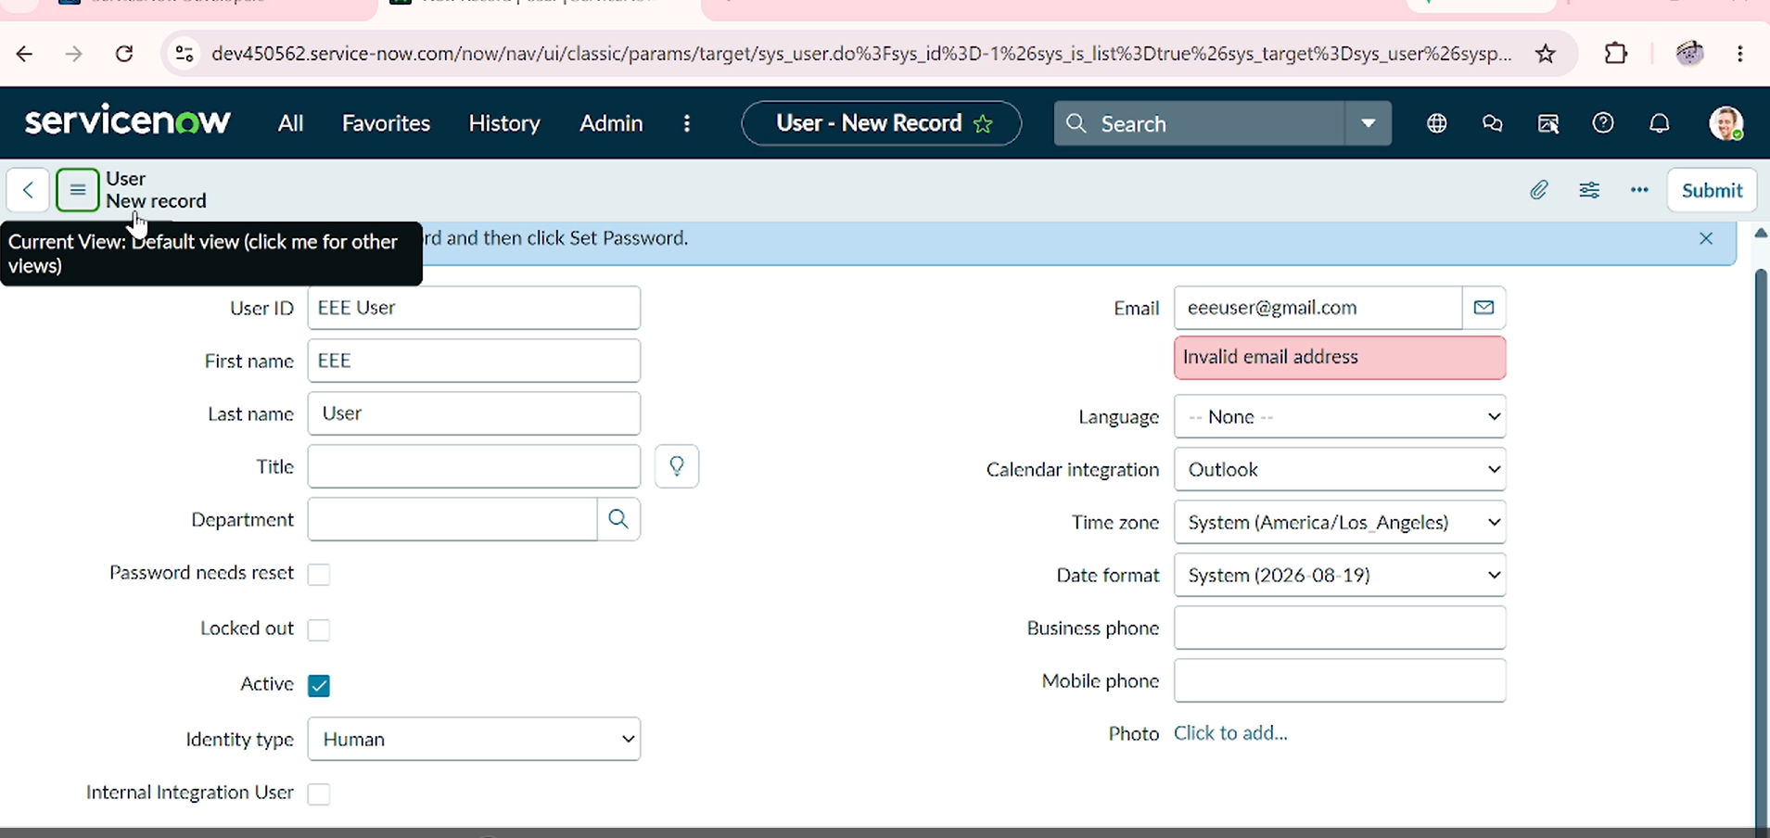
2. Data Preprocessing | No separate preprocessing process is specified. Create sample Institution Details records with Branch values ECE, EEE and CSE to test the ACL rules. | 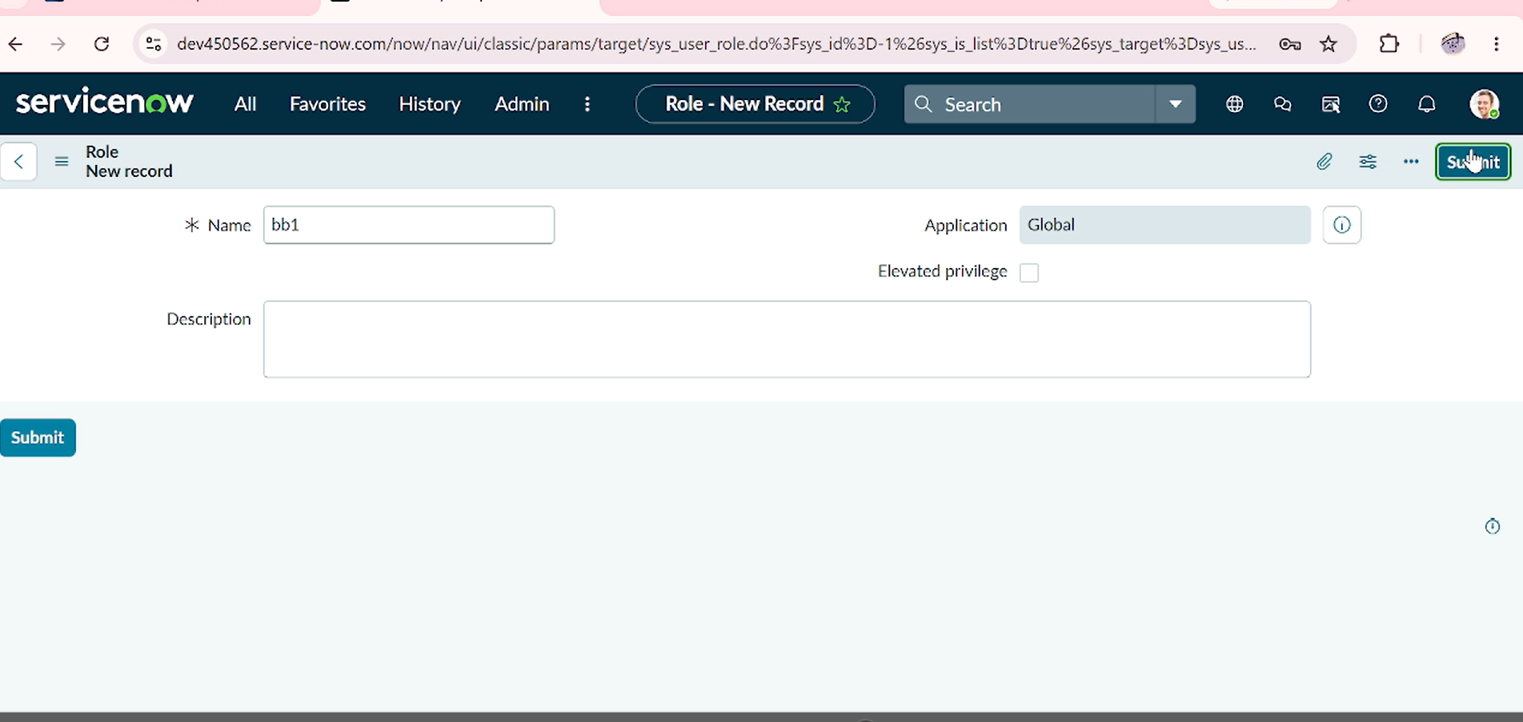
3. Utilization of Data Filters | The READ ACL uses Branch = EEE and requires role bb1. Verify that the EEE user can view EEE records and restricted records are not visible to unauthorized users. The script allows Admin access. | . 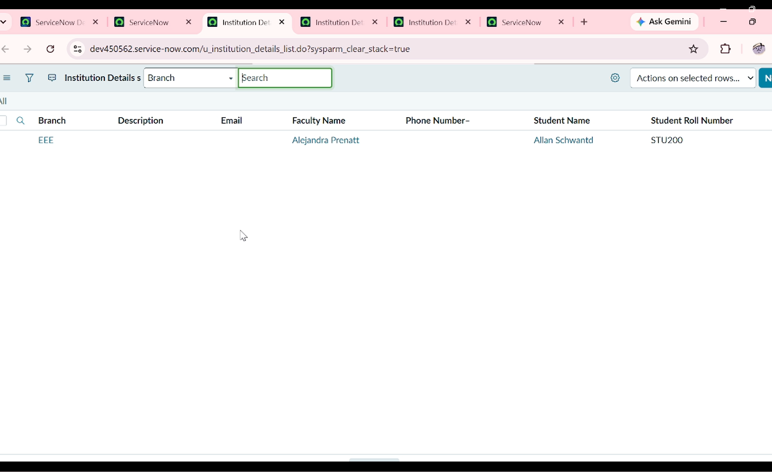
4. DAX Queries Used | Not applicable. DAX is a Power BI language; this is a ServiceNow ACL project. The READ ACL uses a server-side script to check admin and bb1 roles and return true or false. | 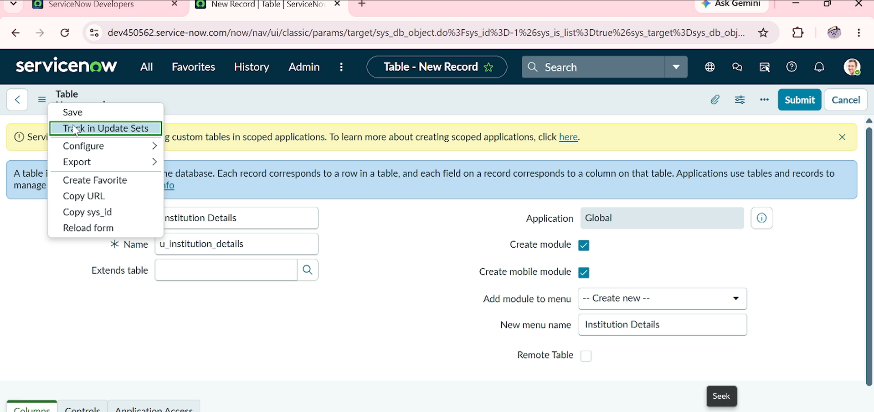
5. Dashboard Design – No. of Visualizations / Graphs | Not applicable. The project uses ServiceNow list and form views, not a Power BI dashboard. Confirm the displayed records and available actions follow the user's permissions. | 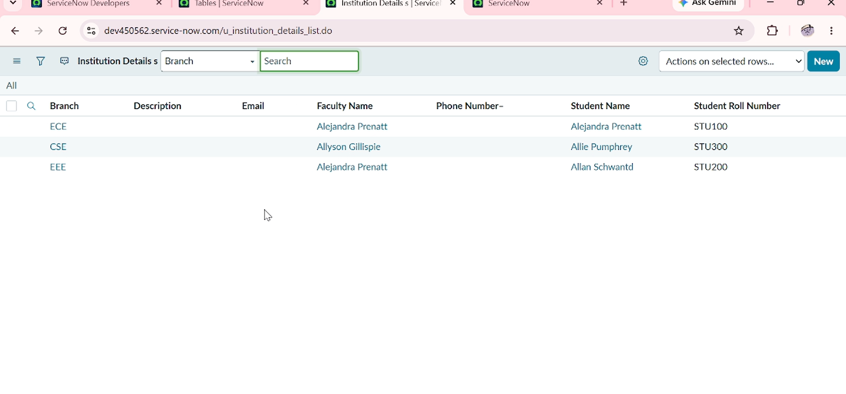
6. Report Design – No. of Visualizations / Graphs | Not applicable. No dashboard charts or report visualizations are specified. Validate CREATE, WRITE and DELETE permissions through the ServiceNow interface. | 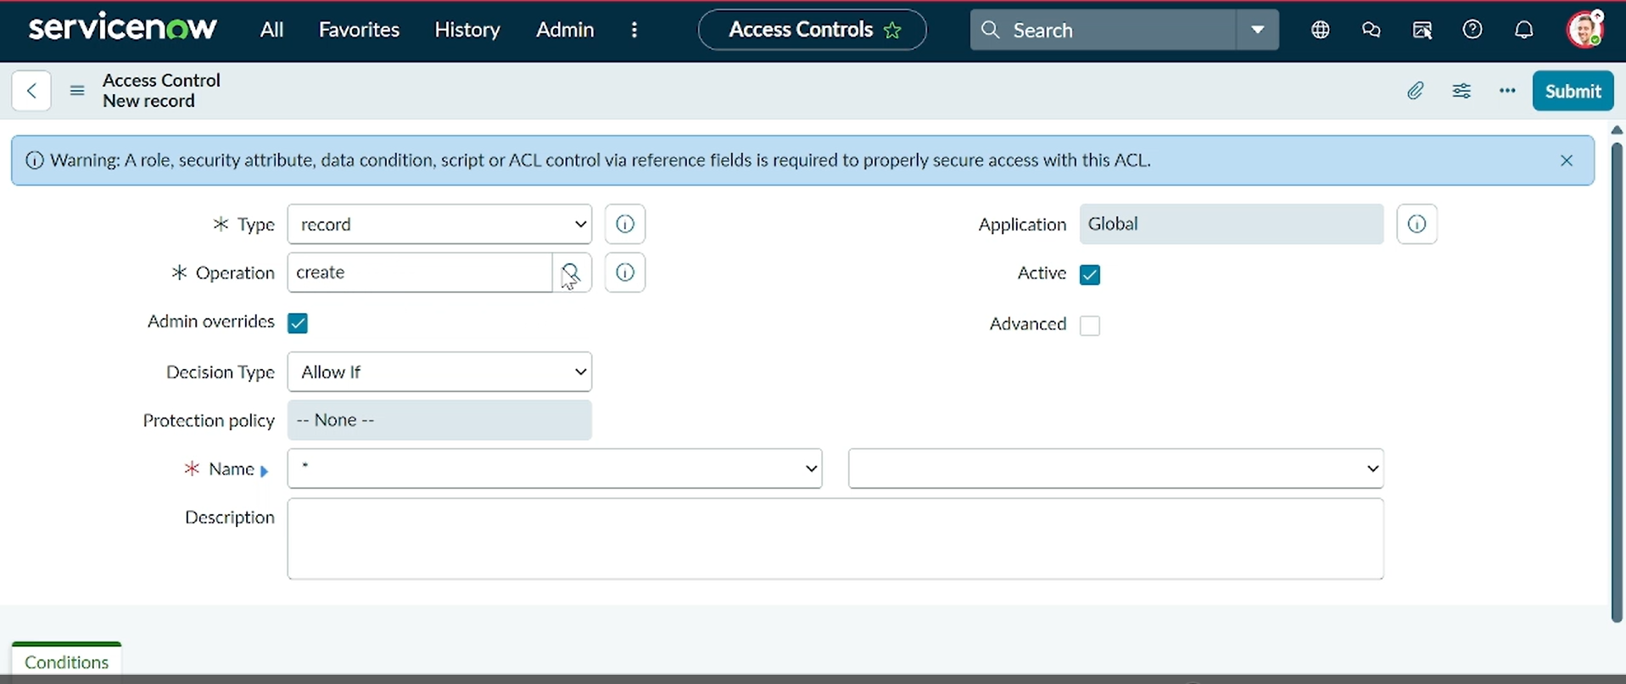

ACL Verification Summary
- READ: bb1 role and Branch = EEE condition restrict record visibility; Admin can view all branches.
- CREATE: bb2 role is required to create records.
- WRITE: bb3 role is required to edit records.
- DELETE: bb4 role is required to delete records.
- Enter actual response times only if measured in your ServiceNow instance; do not invent performance values.
Submission note: Insert actual screenshots from your ServiceNow instance in the evidence column. The reference project demonstrates functional ACL verification and does not state measured performance benchmarks.

